Sumit Vadaviya

Camunda BPM Expert, Corporate Trainer

Email : sumit.vadaviya@trainosoft.com

I

n this session we will have quick overview of camunda Admin web application.

Camunda Admin is an application that allows you to configure users and groups, tenants, authorizations.

Camunda Web Application (Admin)

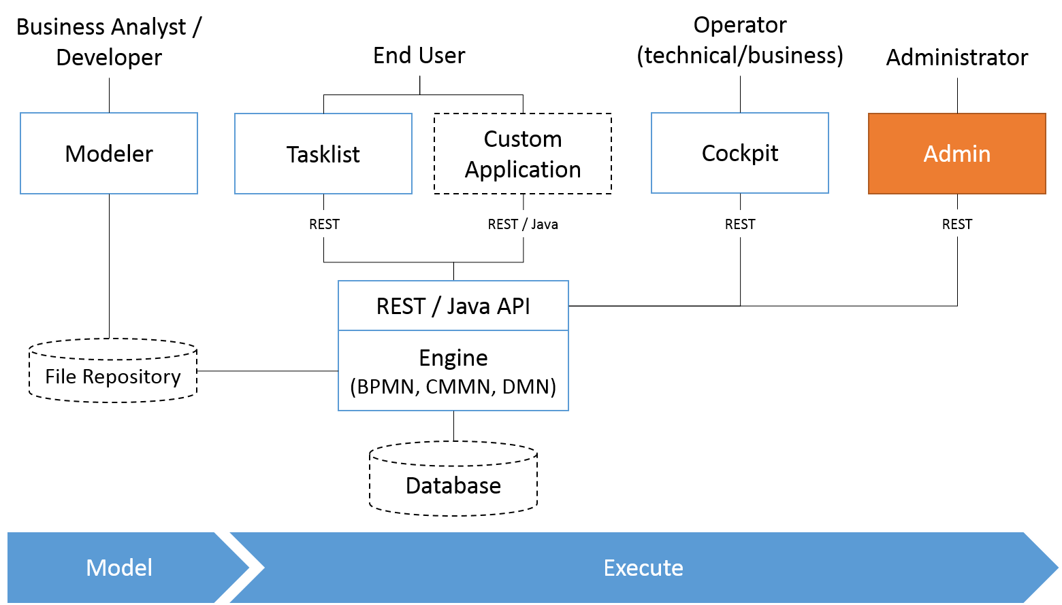

1. **Login to camunda welcome app and navigate to Admin application.**

**URL:** <http://localhost:8081/camunda>

**Username:** demo

**Password:** demo

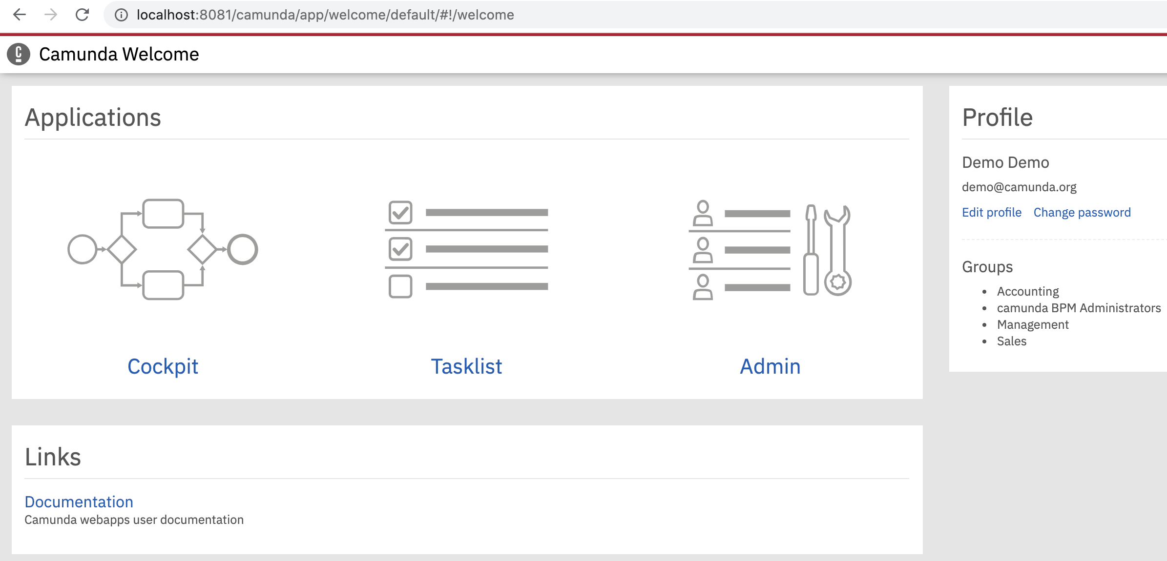

**2. Admin application landing screen**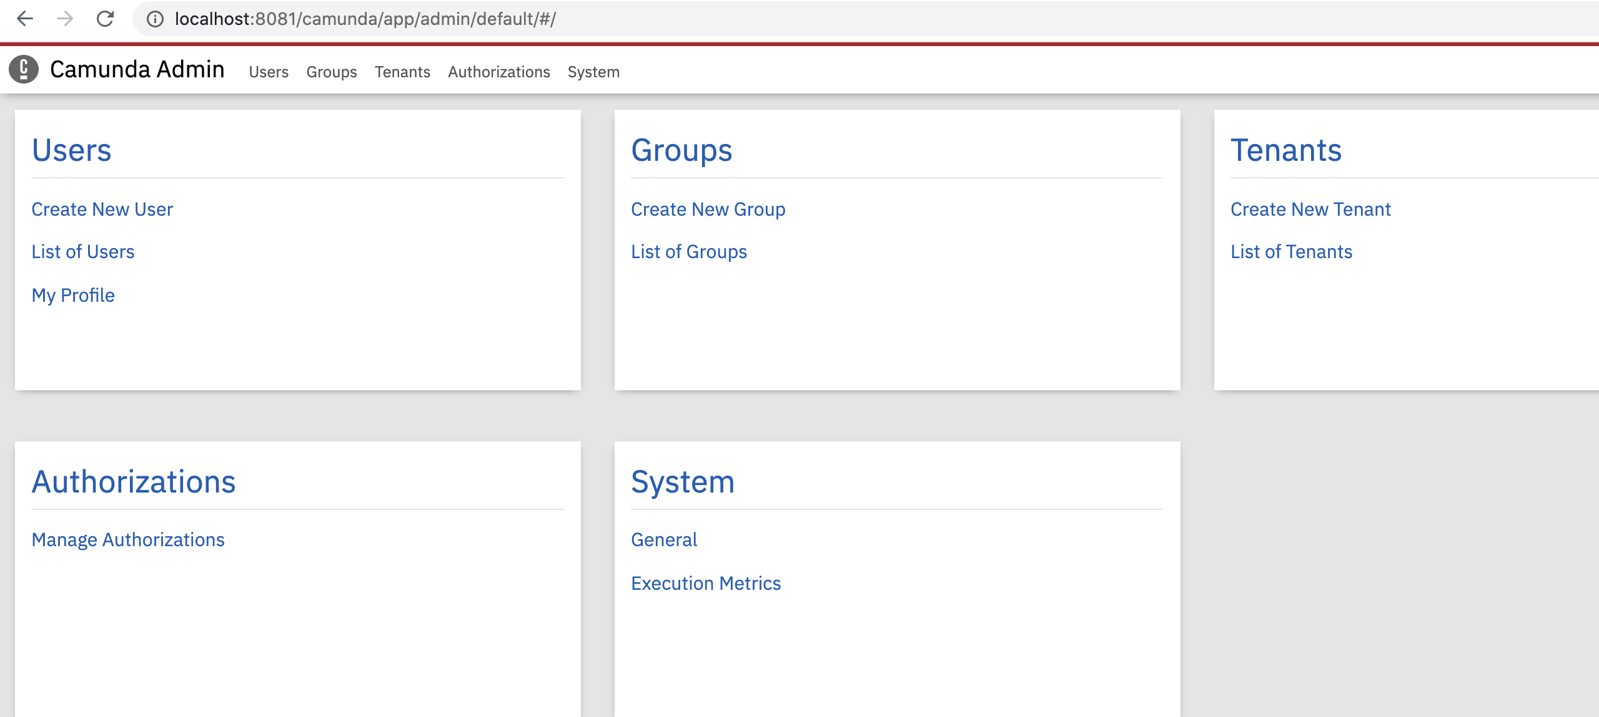

We will go through each components of camunda admin application.

1. **Users**

The Users menu allows you to add, edit and delete user profiles. Furthermore, you can manage group membership and change passwords.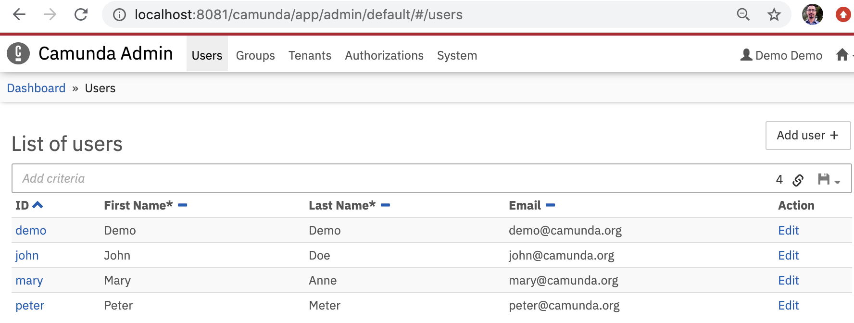

To manage profile, account, groups and tenants for user click on Edit action.

**3.1 User profile:** Users first name, last name and email can be updated.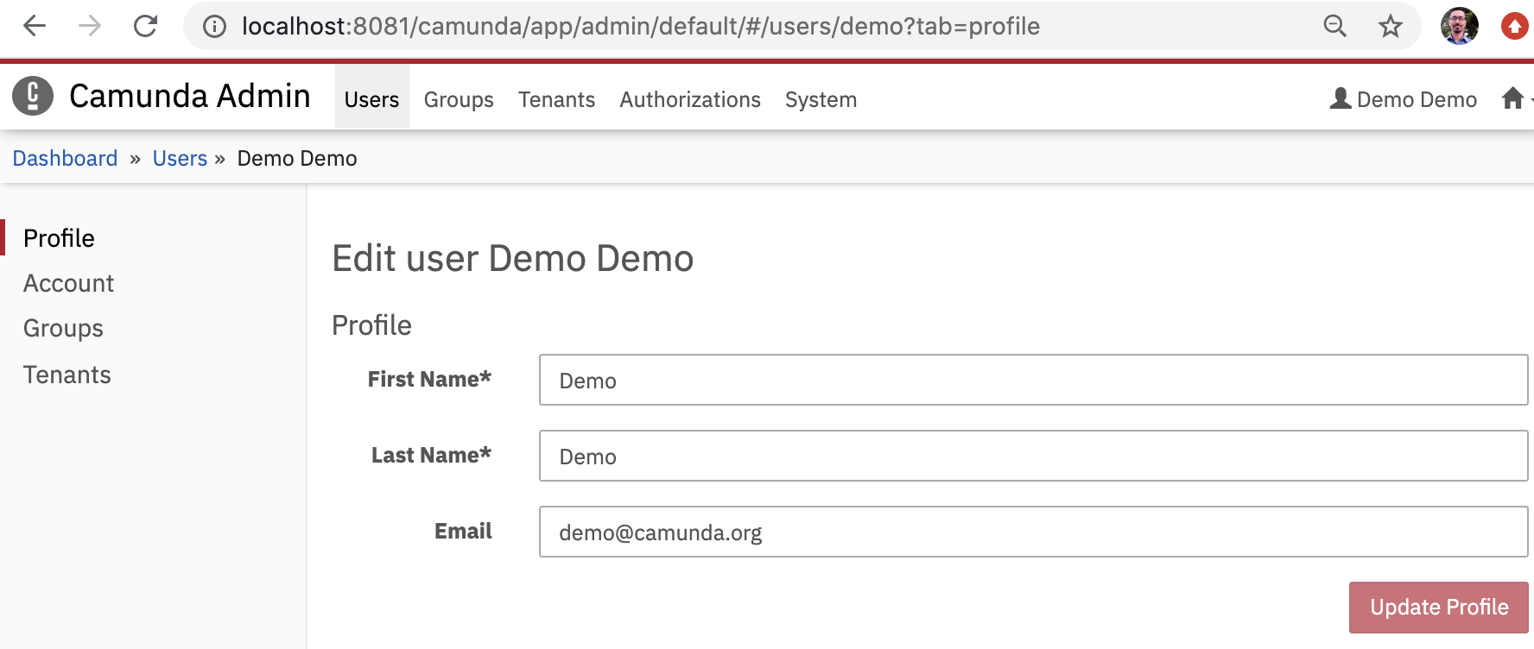

**3.2 Account:** Change your password or delete/unlock your account. Be careful, deletion cannot be undone.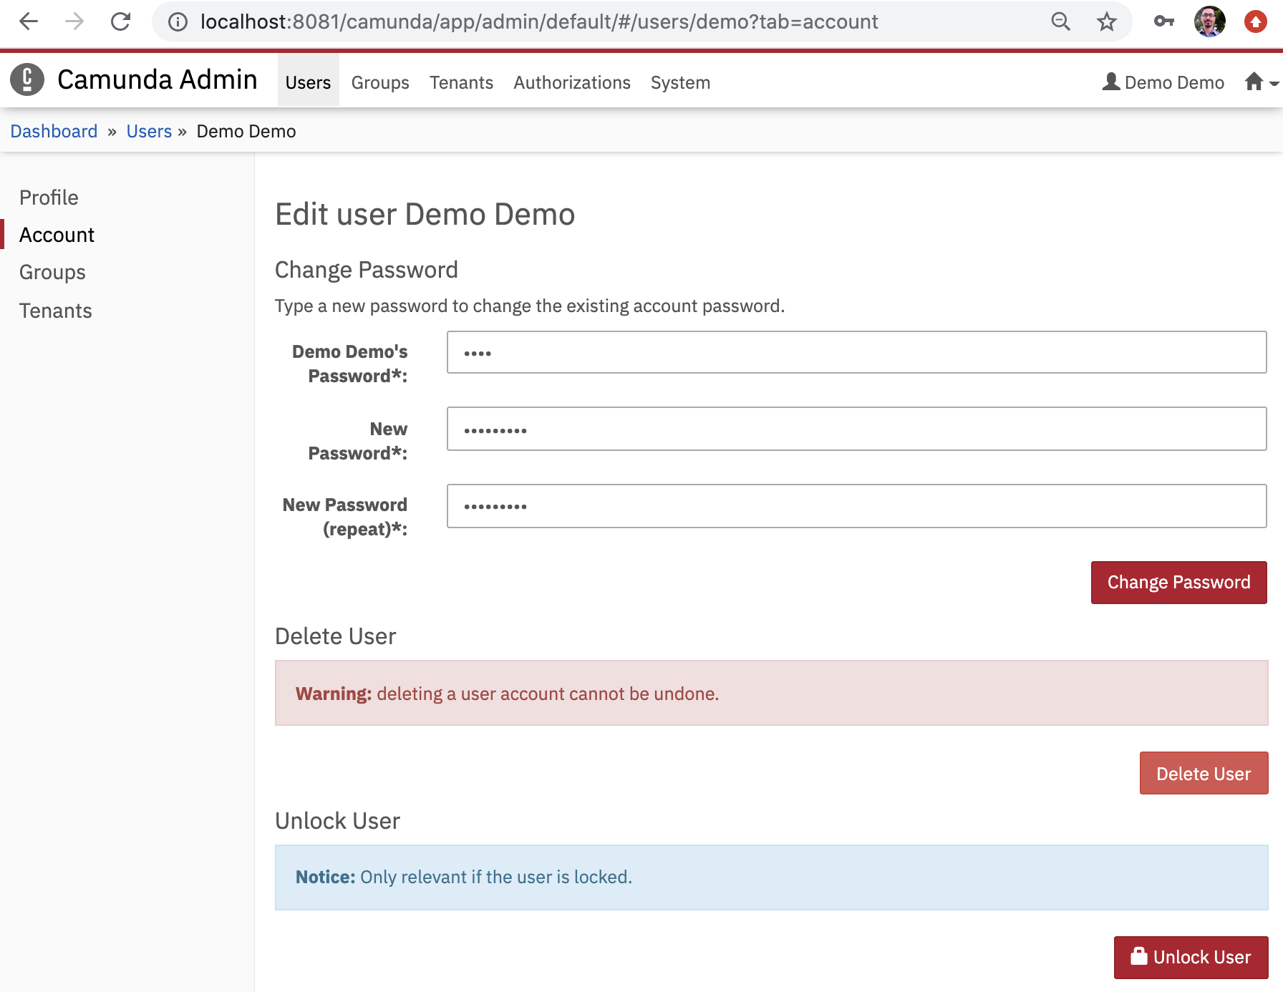

**3.3 Groups:** This menu lists all groups of which you are member. With administrator rights you can assign your account to the available groups.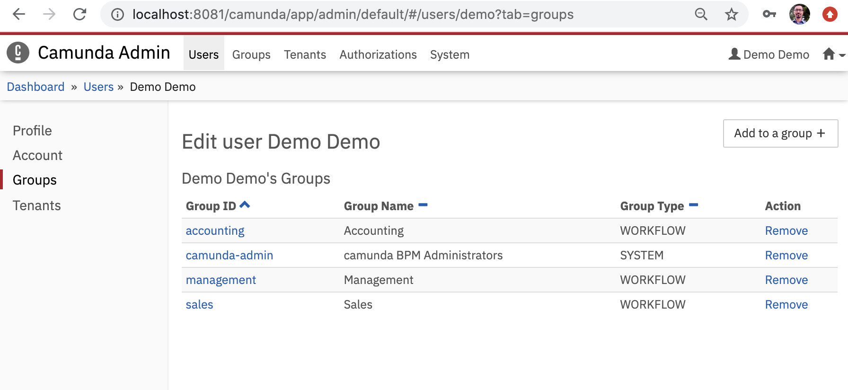

**3.4 Tenants:** This menu lists tenants of which user is member of. With administrator rights you can assign tenant to the user.

1. **Groups**

The Groups menu allows you to add, edit and delete user groups. Beside that you can view the members of groups and each group member’s tenant.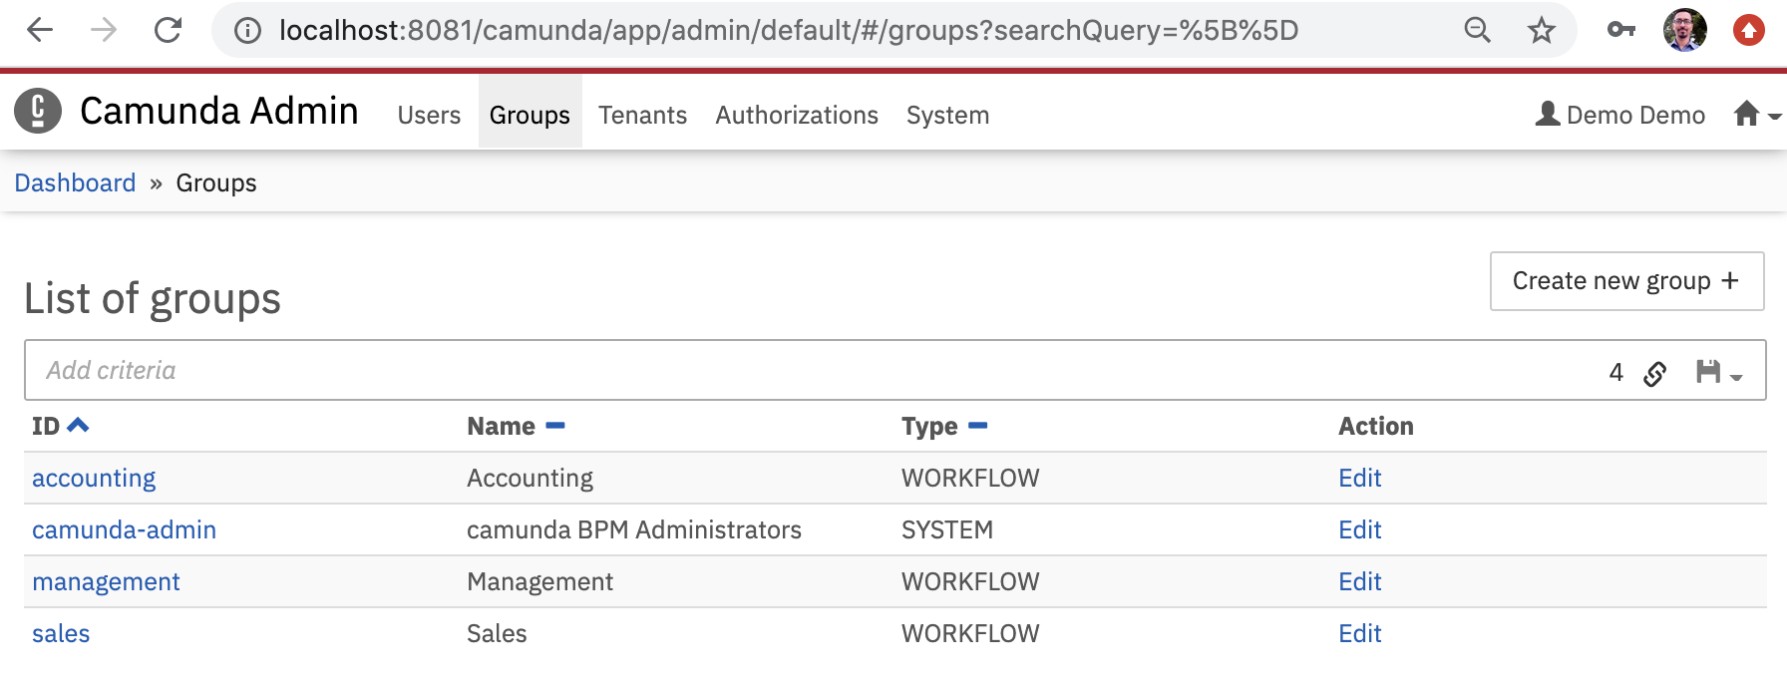

Click on the group accounting to view its information.

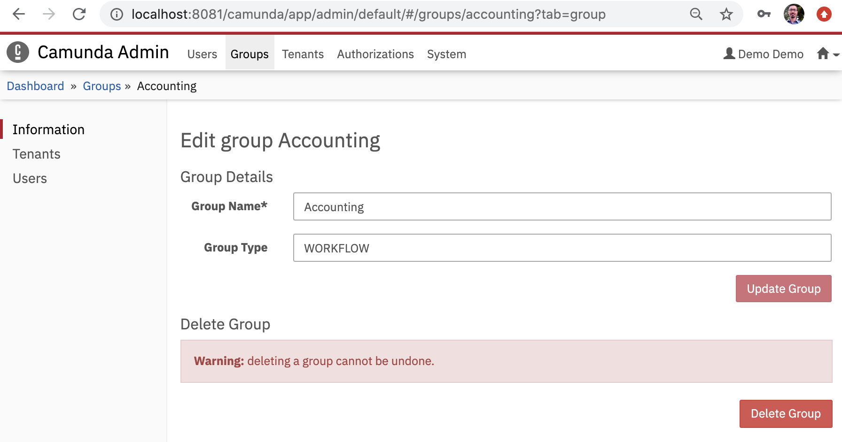

Click on the users to view users associated with group.

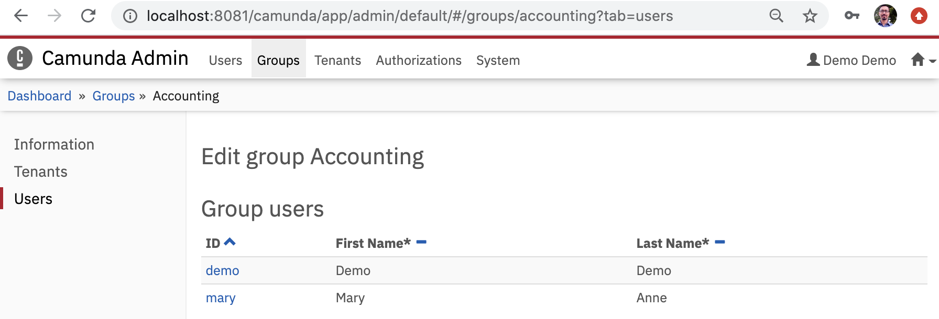

1. **Tenants**

The Tenants menu allows you to add, edit and delete tenants. Beside that you can view which user or group is a member of a tenant.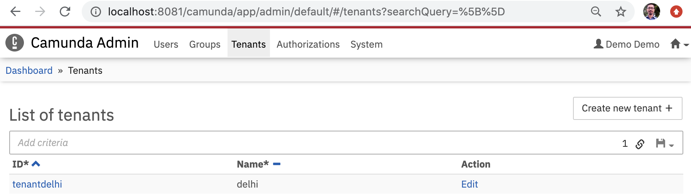

**Create a new tenant**

All you have to do to create a new tenant is:

1. Click the Create new tenant button
2. Type the Tenant Id and Tenant Name in the corresponding input fields
3. Click the Create new Tenant button

This creates a new tenant.

**Add an user to a tenant**

* To add an user to a tenant you have to go to the users account settings and click on the Tenants menu on the left side.
* In this menu you can click the Add to a tenant button and select the tenants where the user should be a member.

**Add a group to a tenant**

* To add a group to a tenant you have to go to the group settings and click on the Tenants menu on the left side.
* In this menu you can click the Add to a tenant button and select the tenants where the group should be a member.

1. **Authorizations**

Manage authorizations for a variety of resources (e.g.,  Applications, Groups, Filters).

You can grant access of

* Applications
* Filter Access
* Decision Definition
* Deployment
* Tenant
* Application specific permissions (Through cockpit)
  + Process definition,
  + Process instance, Task
  + Tasks

1. **System**

The System Settings menu gives you some general information about the process engine and allows you to access the Execution Metrics 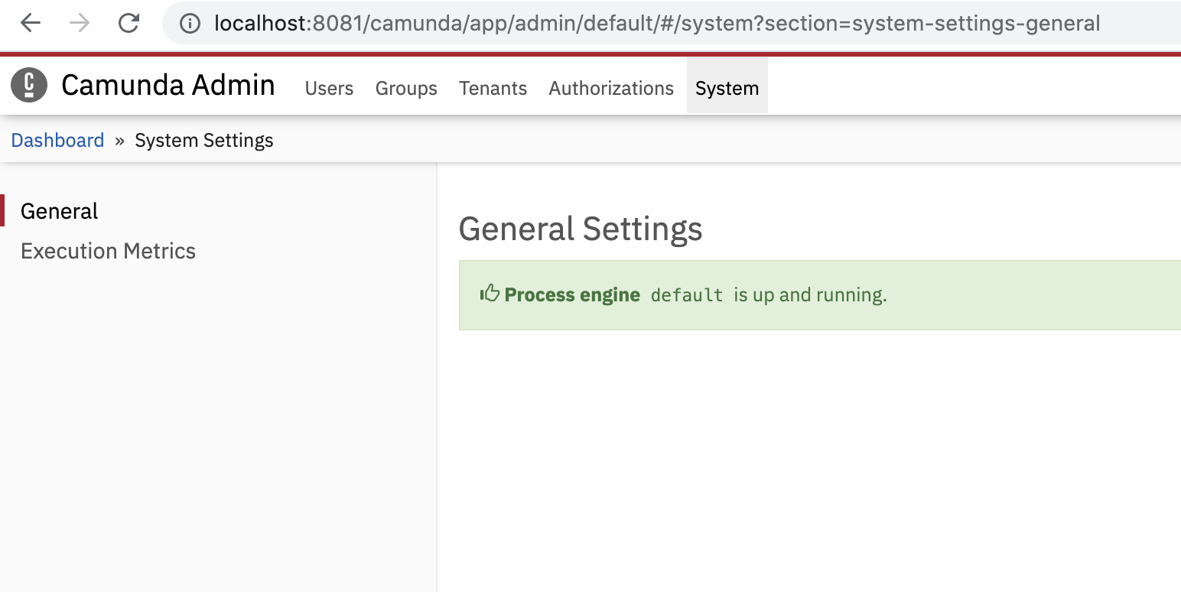

**The Execution Metrics** : Displays an approximate number of Root Process Instances (RPI), Flow Nodes Instances (FNI), Executed Decision Instances (EDI) and Executed Decision Elements (EDE) that have been processed by the engine within a specified time range.